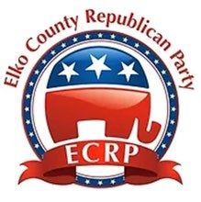

A RESOLUTION IN HONOR AND LOVING MEMORY OF CHARLES JAMES KIRK

WHEREAS, At just eighteen years old, Charlie founded Turning Point USA, an organization that grew into one of the largest, most impactful conservative youth organizations in the nation; and

WHEREAS, Charlie spent over a decade tirelessly traveling the country leading a movement to restore respect for our founding principles, reawaken our national identity, and inspire a renewed spirit of religious devotion; and

WHEREAS, Charlie helped mobilize thousands of young students to stand up for these values and get involved in politics; and

WHEREAS, Even in the face of repeated threats, Charlie displayed unwavering commitment to spreading Judeo-Christian values and modeling courage, logic, humor, and grace to the next generation; and

WHEREAS, On September 10, 2025, the American people tragically lost a faithful servant, cherished son, loving father, devoted husband, fierce patriot, and brilliant visionary;

BE IT THEREFORE RESOLVED, That Charlie Kirk will be remembered for his faith, devotion, honesty, compassion, courage, and patriotism;

RESOLVED, That the Elko County Republican Party will remember and honor Charlie Kirk’s lifetime of accomplishments defending truth and freedom and for his contributions to the Republican Party.

This resolution adopted by the Elko County Republican Party in Convention on 21 February 2026.

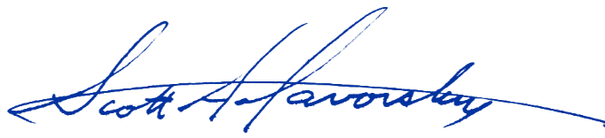
________________________________
Scott A. Gavorsky
Chair, Elko County Republican Party

